 |  | PAYMENT AUTHORIZATION
TRAVELLER NAMES
METHOD OF PAYMENT
Form of Payment |  |  | Name on Card |  | Credit Card Type
Card Number |  |  | Expiration Date |  | Verification Code
What is this? See Below.
Billing Address |  |  |  | City
State |  | Postal Code |  | Country

Business Phone |  | Fax Number |  | E-mail Address

PAYMENT ACKNOWLEDGEMENT
By returning this document to Total Travel Marine with my name and amount, I acknowledge the following.

I, |  | authorize Total Travel Marine to charge the above listed credit
card for the total amount of |  | $ .

For Internal Use Only

Invoices: ______________________

VERIFICATION CODE DETAILS
For your security, we collect the customer verification number from your bank card to prevent the fraudulent use of your account. The customer verification number is a non-embossed number located on your card that cannot be obtained easily by using an imprint of your card or simply copying down the account number.
For your safety, this number is required to verify your charges with us.
What is CVV2?

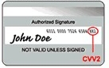 |  | CVV2 is a new authentication scheme established by credit card companies to further efforts towards reducing fraud for internet transactions. It consists of requiring a card holder to enter the CVV2 number in at transaction time to verify that the card is on hand.
Visa & MasterCard:
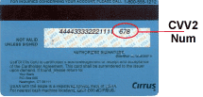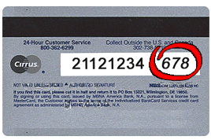 |  | If you are using a Visa, Mastercard or Discover, please provide the 3-digit verification number found on the back of your card.  This is a non-embossed number printed on the signature panel on the back, immediately following the account number.  This number is printed on your MasterCard & Visa cards in the signature area of the back of the card. (it is the last 3 digits AFTER the credit card number in the signature area of the card).
American Express:
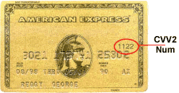 | American Express cards show the cvv2 printed above and to the right of the imprinted card number on the front of the card. If you are using an American Express card, please provide the 4-digit verification number found on the front of your card.

